**CH 5. Initiating and Planning Systems Development Projects**

* 描述 the steps involved in the project initiation and planning process.
* 說明 the need for and the contents of a Project Scope Statement and Baseline Project Plan.
* 列出與描述various methods for assessing project feasibility.
* 描述the differences between tangible and intangible benefits and costs, and between one-time vs. recurring benefits and costs.
* 執行cost-benefit analysis and 描述 what is meant by the time value of money, present value, discount rate, net present value, return on investment, and break-even analysis.
* 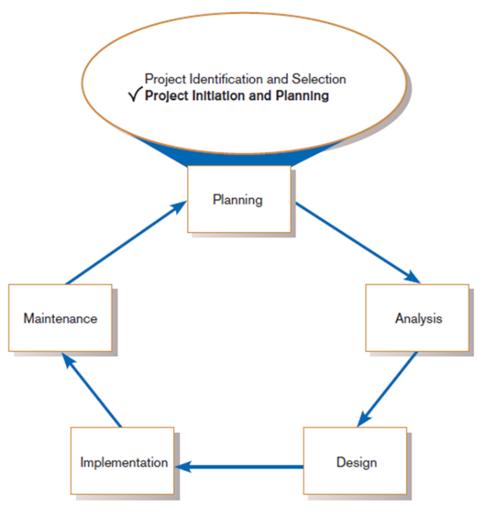描述the general rules for evaluating technical risks associated with a systems development project.
* 描述 the activities and participant roles within a structured walkthrough.(逐步指令)

1. **Initiating and Planning Systems Development Projects**
   * What must be considered when making the decision on the division between project initiation and planning (PIP) and analysis?
     + How much effort should be expended on the PIP process?

* Size, scope, complexity, and experience
* 10%-20% of development effort
  + - Who is responsible for performing the PIP process?
* An experienced system analyst or a team of analysts working with the proposed customers of the system and other technical development staff
  + - Why is PIP such a challenging activity?
* PIP study is to transform vague system requests from different parties into a tangible project description

1. **Initiating IS Development Projects**
   * 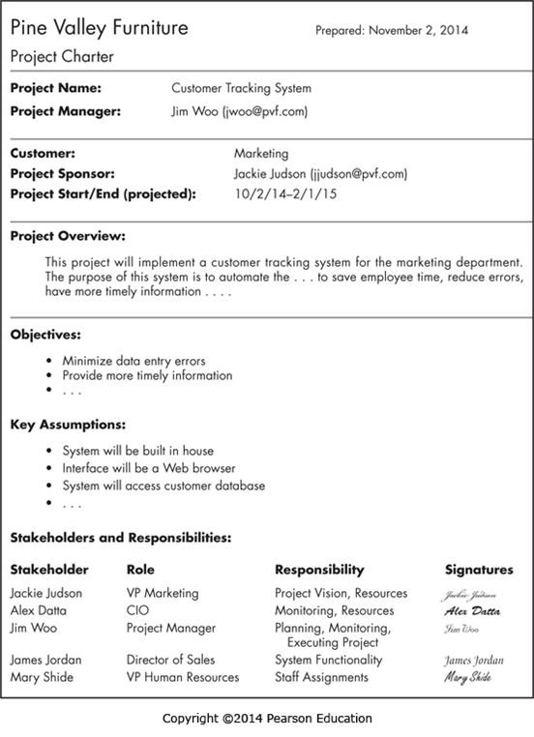Project initiation focuses on activities designed to assist in organizing a team to conduct project planning.

* Establishing the Project Initiation Team (who ?)
* Establishing a Relationship with the Customer
* Establishing the Project Initiation Plan
* Establishing Management Procedures
* Establishing the Project Management Environment and Project Workbook
* Developing the Project Charter (see Ch 3)
  + The key activity of project planning is the process of defining clear, discrete activities and the work needed to complete each activity within a single project.
  + The objective of the project planning process is the development of a Baseline Project Plan (BPP), the Project Scope Statement (PSS), and Business Case

1. **Elements of Project Planning**
   * Describe project scope, alternatives, feasibility.
   * Divide project into tasks.
   * Estimate resource requirements and create resource plan.
   * Develop preliminary schedule.
   * Develop communication plan.
   * Determine standards and procedures.
   * Identify and assess risk.
   * Create preliminary budget.
   * Develop a statement of work.
   * Set baseline project plan.
2. **Deliverables and Outcomes**
   * **Baseline Project Plan (BPP)**

* A major outcome and deliverable from the PIP phase
* Contains the best estimate of a project’s scope, benefits, costs, risks, and resource requirements
  + **Project Scope Statement (PSS)**
* A document prepared for the customer
* Describes what the project will deliver
* Outlines at a high level all work required to complete the project
  + **Business Case**
* Justification for an information system
* Presented in terms of the tangible and intangible economic benefits and costs
* The technical and organizational feasibility of the proposed system

1. **Building the Baseline Project Plan**
   * A **Baseline Project Plan (BPP)** is a document intended primarily to guide the development team.
   * Sections:

* Introduction
* System description
* Feasibility assessment
* Management issues
  + System description section outlines possible alternative solutions.
* E.g., Web-based online system, mainframe with central DB, LAN with decentralized DB, batch data input with online retrieval, purchasing of a prewritten package, ……
  + Feasibility assessment section outlines issues related to project costs and benefits, technical difficulties, and other such concerns.
* A high-level project schedule should also be specified
* Greatest amount of project planning effort
  + Management issues section outlines a number of managerial concerns related to the project. 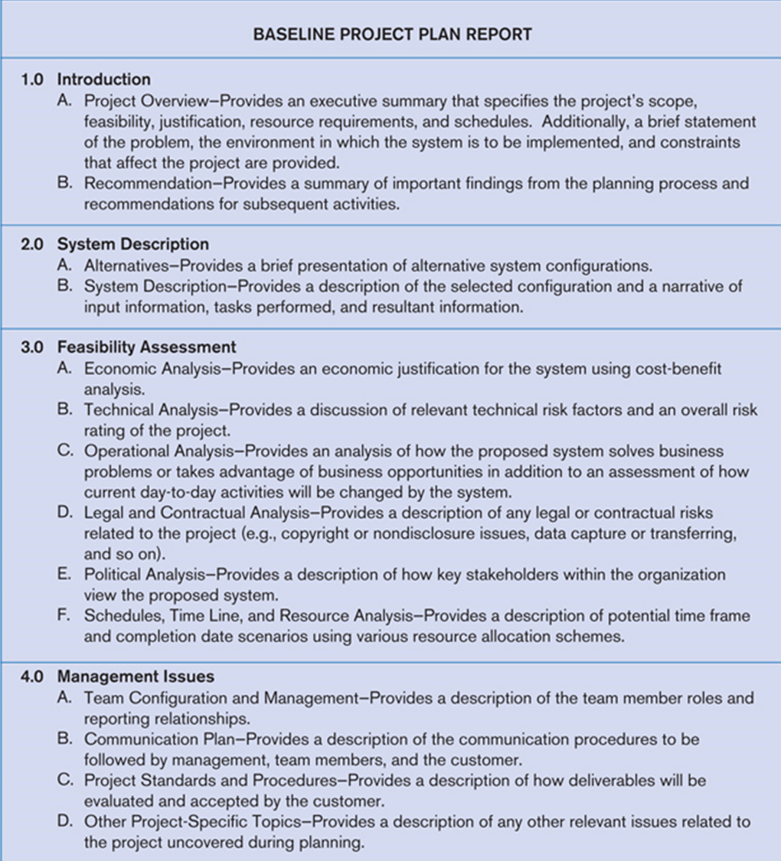
  + 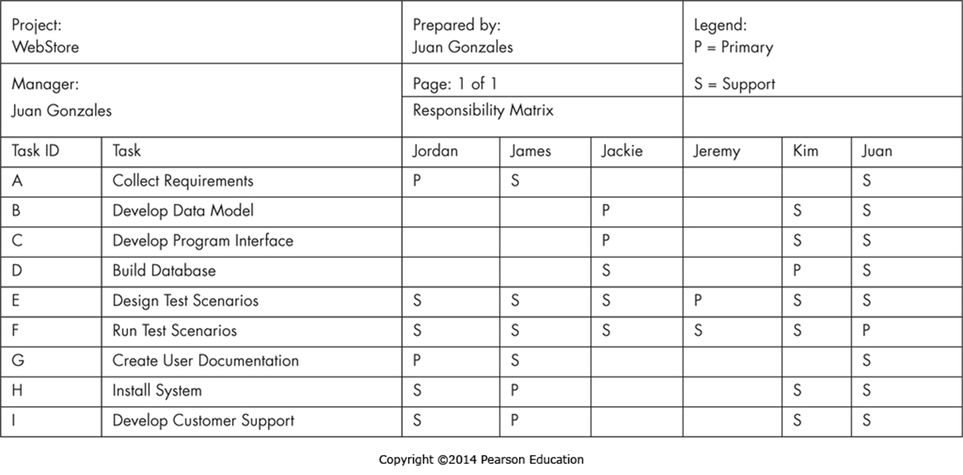Task Responsibility Matrix
  + 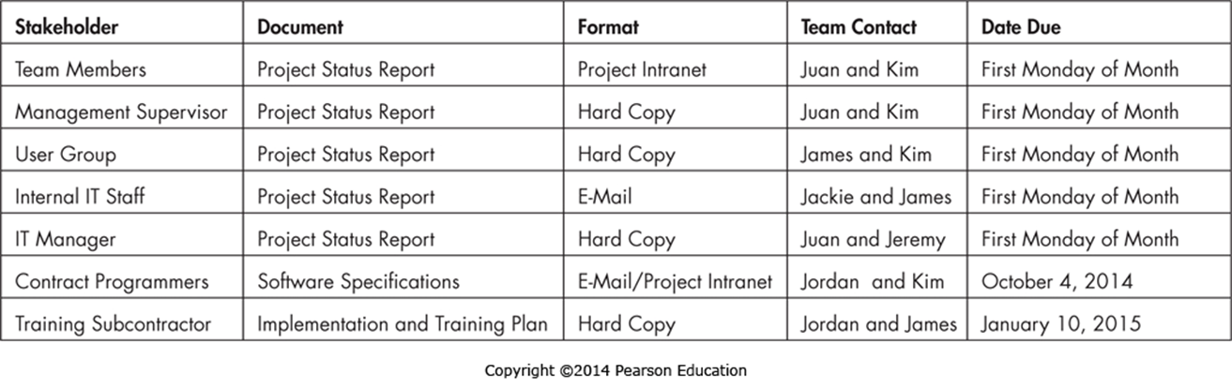The Project Communication Matrix

1. **Reviewing the Baseline Project Plan**
   * **Structured Walkthroughs(逐步確認)**: a peer-group review of any product created during the system development process

* 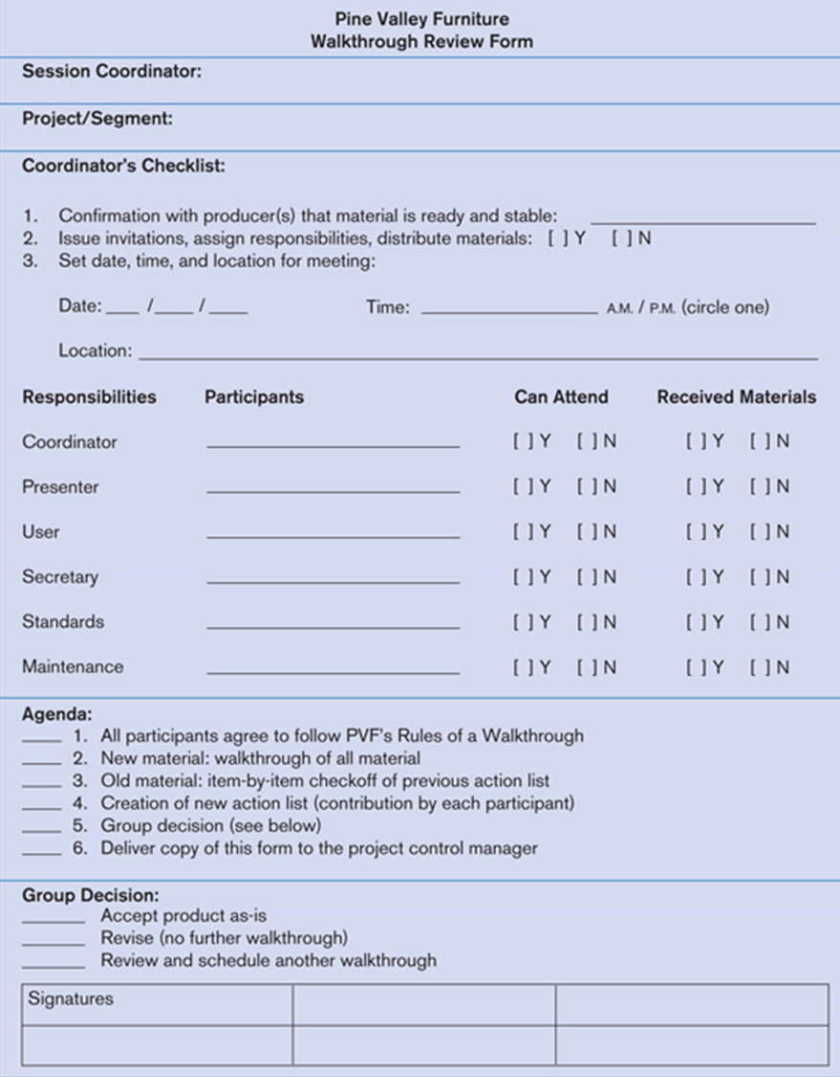Roles in a walkthrough meeting: coordinator, presenter, user, secretary, standard-bearer, maintenance oracle
* Can be applied to BPP, system specifications, logical and physical designs, program code, test procedures, manuals and documentation

1. **Factors in Determining Scope**
   * Organizational units affected by new system
   * Current systems that will interact with or change because of new system
   * People who are affected by new system
   * 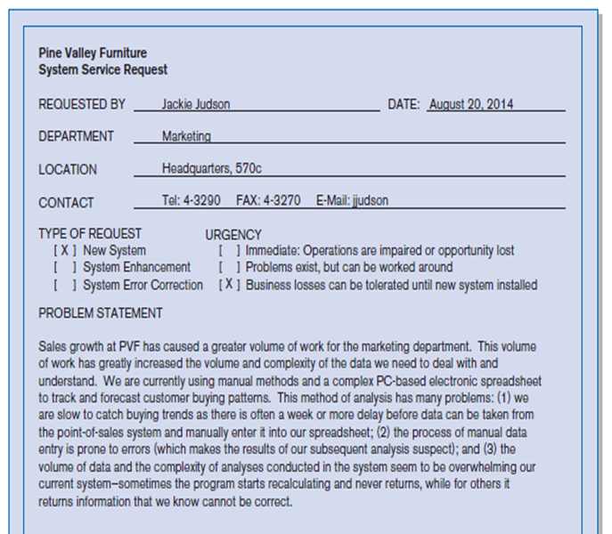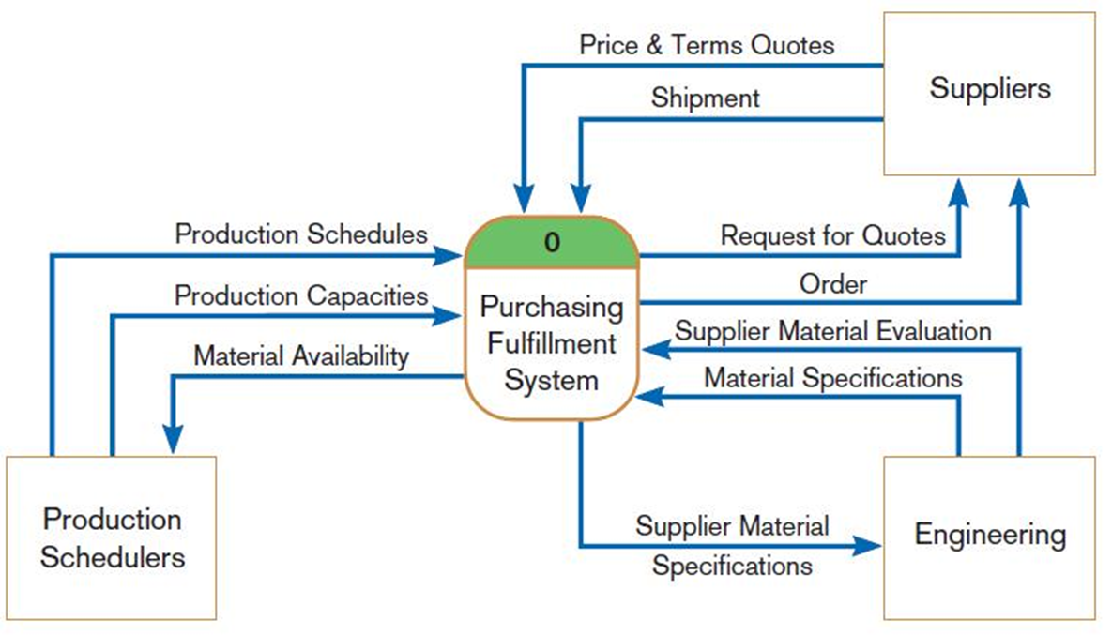Range of potential system capabilities
2. **Assessing Project Feasibility**

* Economic
* Technical
* Operational
* Scheduling
* Legal and contractual
* Political

1. **Assessing Economic Feasibility**
   * **Economic feasibility:** a process of identifying the financial benefits and costs associated with a development project

* Often referred to as a cost-benefit analysis
* Project is reviewed after each SDLC phase in order to decide whether to continue, redirect, or kill a project

1. **Determining Project Benefits**
   * **Tangible benefits** refer to items that can be measured in dollars and with certainty.

E.g.,

* reduced personnel expenses
* lower transaction costs, or
* higher profit margins.
  + Most tangible benefits will fit within the following categories:
* Cost reduction and avoidance
* Error reduction
* Increased flexibility
* Increased speed of activity
* Improvement of management planning and control
* Opening new markets and increasing sales opportunities

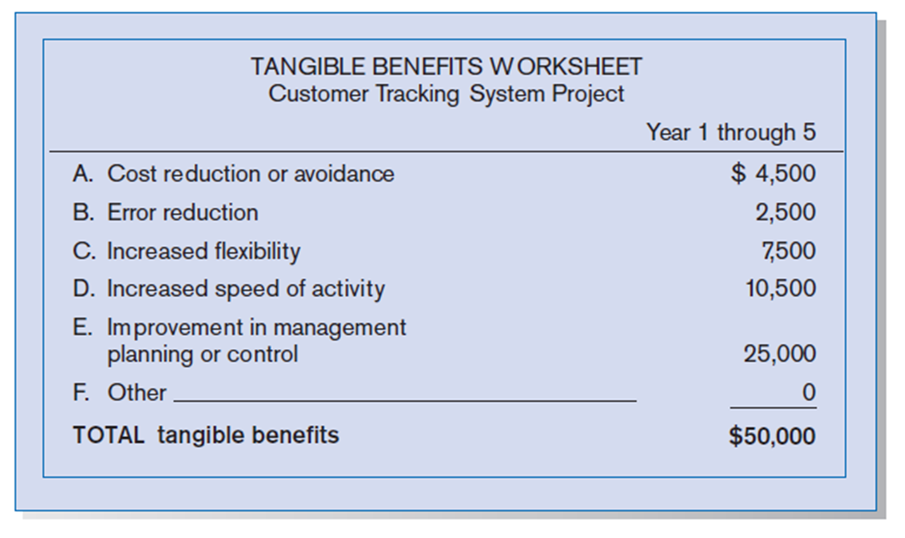

* + **Intangible benefits** are benefits derived from the creation of an information system that cannot be easily measured in dollars or with certainty.
* May have direct organizational benefits, such as the improvement of employee morale
* May have broader societal implications, such as the reduction of waste creation or resource consumption

1. **Determining Project Costs**
   * **Tangible cost:** a cost associated with an information system that can be measured in dollars and with certainty
   * 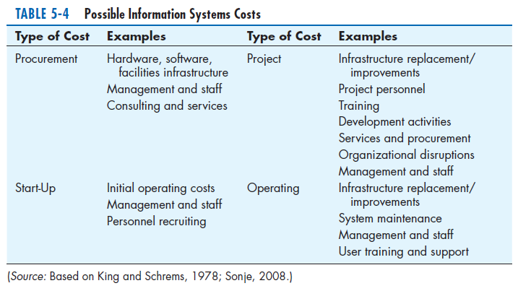IS development tangible costs include:

* 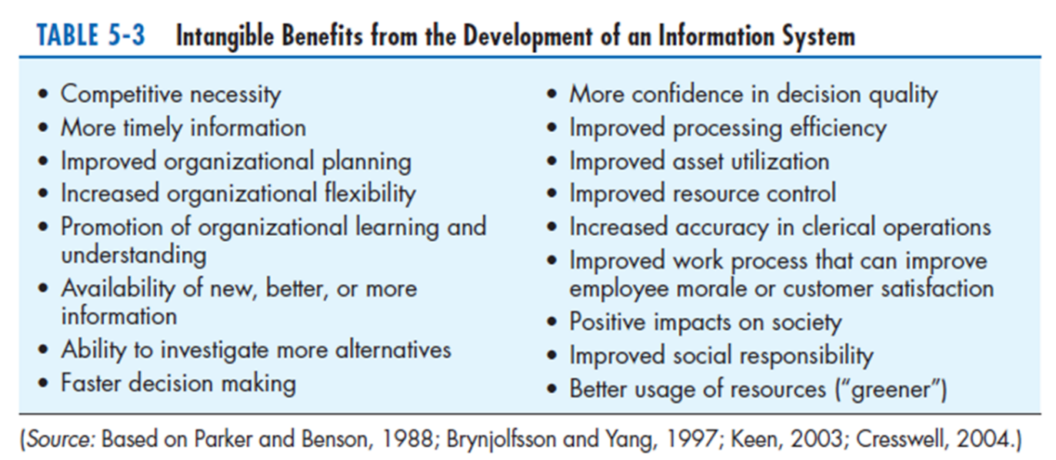Hardware costs, Labor costs, or Operational costs, including employee training and building renovations.
  + **One-time cost:** a cost associated with project start-up and development or system start-up

e.g.

* Systems development,
* New hardware and software purchases,
* User training,
* Site preparation, and
* 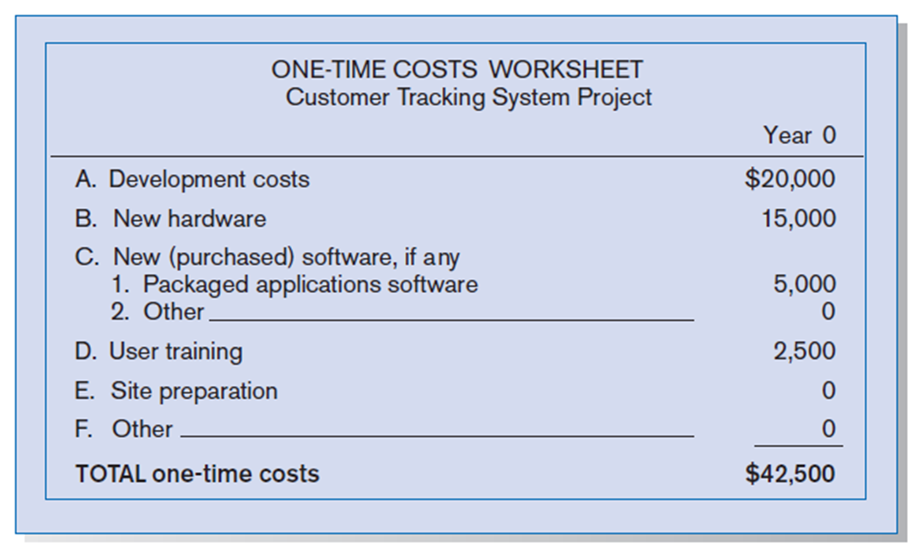Data or system conversion.
  + **Recurring cost**: a cost resulting from the ongoing evolution and use of a system

e.g.

* Application software maintenance
* Incremental data storage expenses
* Incremental communications
* New software and hardware leases, and
* Supplies and other expenses (i.e., paper, forms, data center personnel).

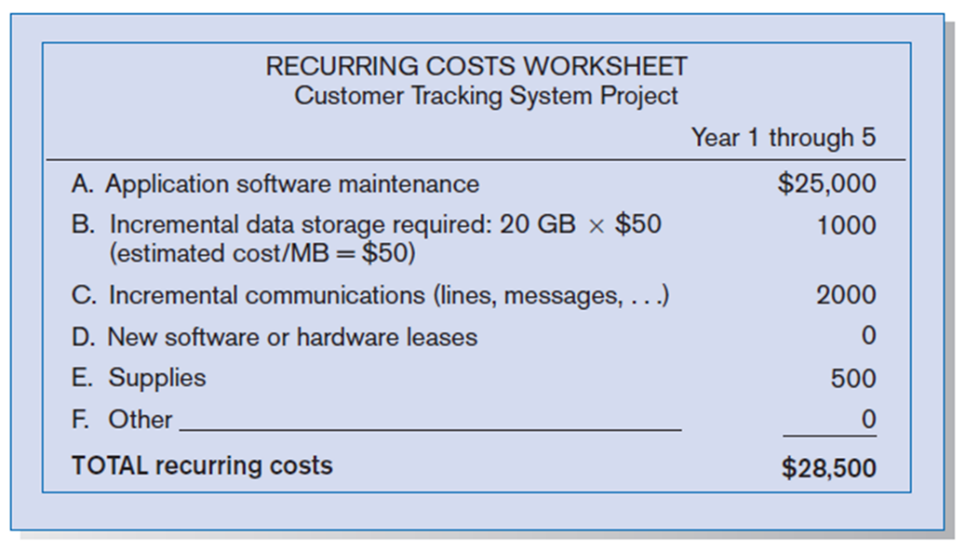

* + Both one-time and recurring costs can consist of items that are fixed or variable in nature.
* **Fixed costs** are billed or incurred at a regular interval and usually at a fixed rate.
* E.g., facility lease payment
* **Variable costs** are items that vary in relation to usage.
* 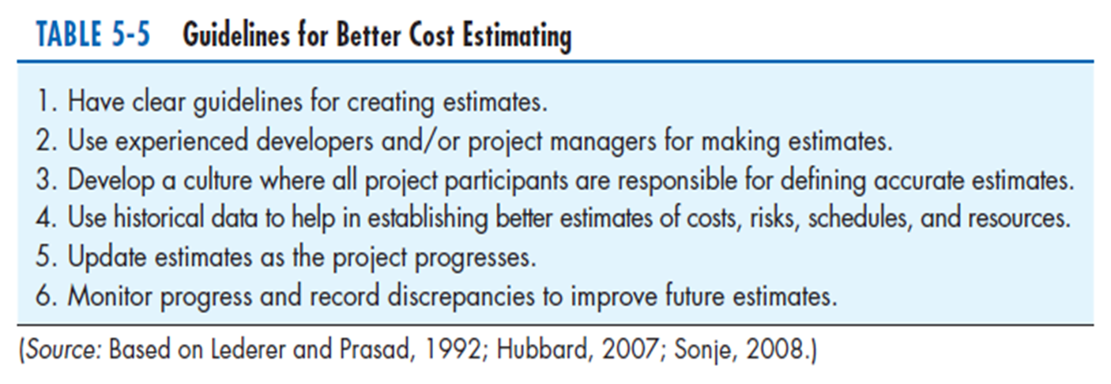E.g., long-distance phone charges

1. **The Time Value of Money**
   * **Time value of money (TVM):** the concept that money available today is worth more than the same amount tomorrow
   * E.g.,

Suppose you want to buy a used car from an acquaintance and she asks that you make 3 payments of $1500 for 3 years, beginning next year, for a total of $4500

If she would agree to a single lump-sum payment at the time of sale, what amount do you think she would agree to? Should the single payment be $4500? Should it be more or less?

* Most of us would gladly accept $4500 today rather than 3 payments of $1500, why?
* Cost of capital: the rate at which money can be borrowed or invested, and is called the **discount rate(折現率)** for TVM calculation
* **Discount rate**: the rate of return used to compute the present value of future cash flows (the cost of capital)
* **Present value**: the current value of a future cash flow



>>

* **Net Present Value**
* NPV = sum of PVs across years.
* The NPV of the three $1500 payments

NPV = PV1 + PV2 + PV3 = 1363.65+1239.60+1126.95 = 3730.20

In other words, the seller could accept a lump-sum payment of $3730.20 as equivalent to the three payments of $1500, given a discount rate of 10%

* + **Return on Investment (ROI)**
    - Ratio of cash receipts to cash outlays
  + **Break-Even Analysis (BEA)**
    - Amount of time required for cumulative cash flow to equal initial and ongoing investment
    - 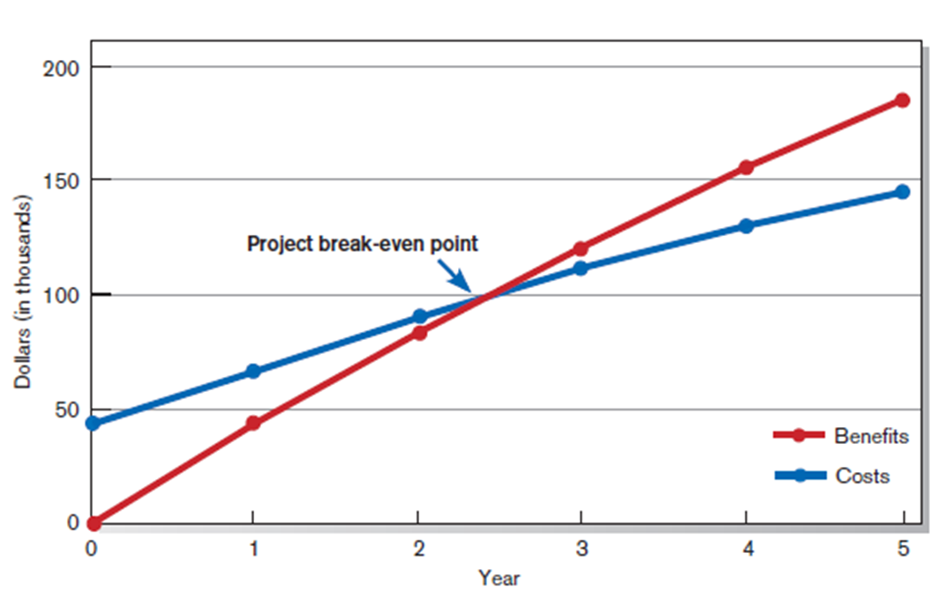A type of cost-benefit analysis to identify at what point (if ever) benefits equal costs

1. **Assessing Technical Feasibility**
   * **Technical feasibility**: a process of assessing the development organization’s ability to construct a proposed system
   * The potential consequences of **not** assessing and managing risks can include:

* Failure to attain expected benefits from the project
* Inaccurate project cost estimates.
* Inaccurate project duration estimates.
* Failure to achieve adequate system performance levels.
* Failure to adequately integrate the new system with existing hardware, software, or organizational procedures.
  + **Four general rules** emerged as technical risk assessments:
    - 1. Larger projects are riskier than smaller projects.
      2. A system in which the requirements are easily obtained and highly structured will be less risky than one in which requirements are messy, ill structured, ill defined, or subject to the judgment of an individual.
      3. The development of a system employing commonly used or standard technology will be less risky than one employing novel or nonstandard technology.
      4. 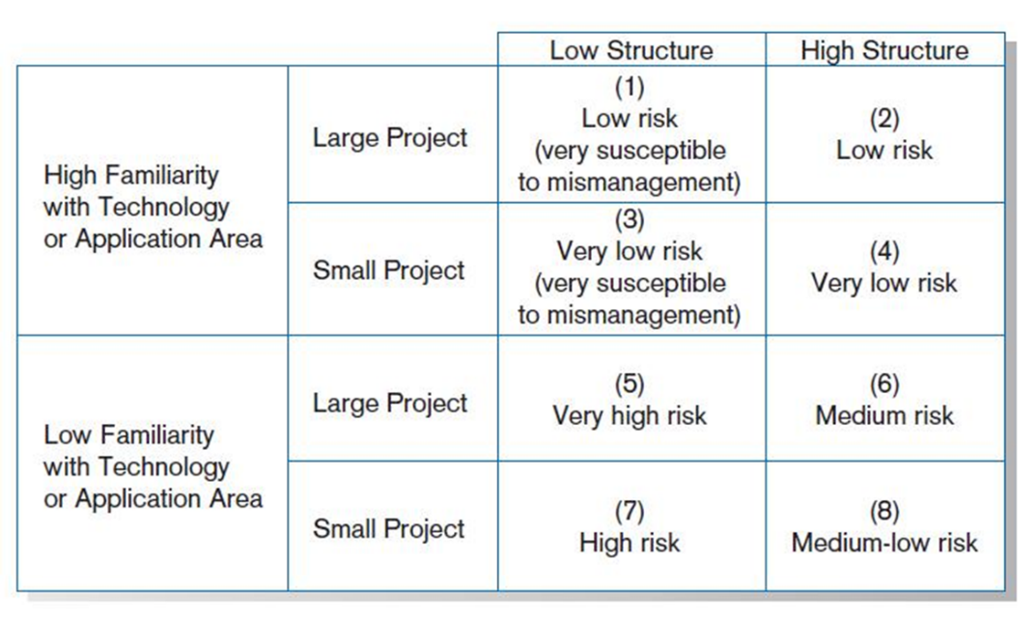A project is less risky when the user group is familiar with the systems development process and application area than if unfamiliar.

1. **Assessing Other Feasibility Concerns**

* Operational
  + - Does the proposed system solve problems or take advantage of opportunities?
* Scheduling
  + - Can the project time frame and completion dates meet organizational deadlines?
* Legal and Contractual
  + - What are the legal and contractual ramifications of the proposed system development project?
* Political
  + - How do key stakeholders view the proposed system?

1. **Project Risk Factors**
   * Project size
     + Team size, organizational departments, project duration, programming effort
   * Project structure
     + New vs. renovated system, resulting organizational changes, management commitment, user perceptions
   * Development group’s experience with the AP and tech area
     + Familiarity with platform, software, development method, application area, development of similar systems
   * User group’s experience with projects and AP area
     + Familiarity with IS development process, application area, use of similar systems
2. 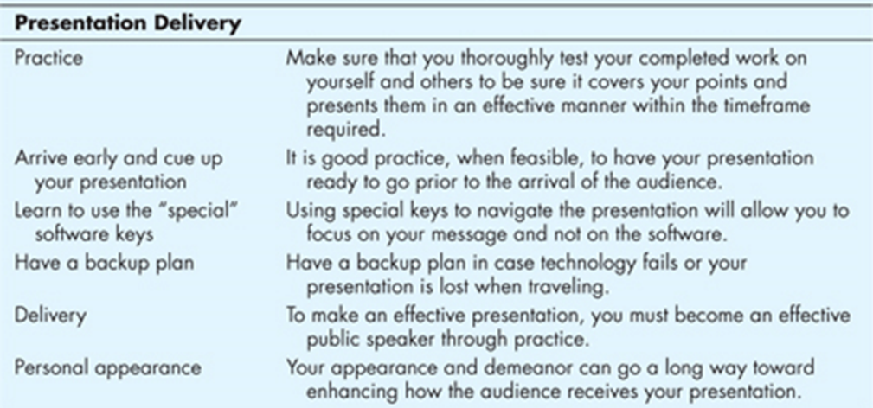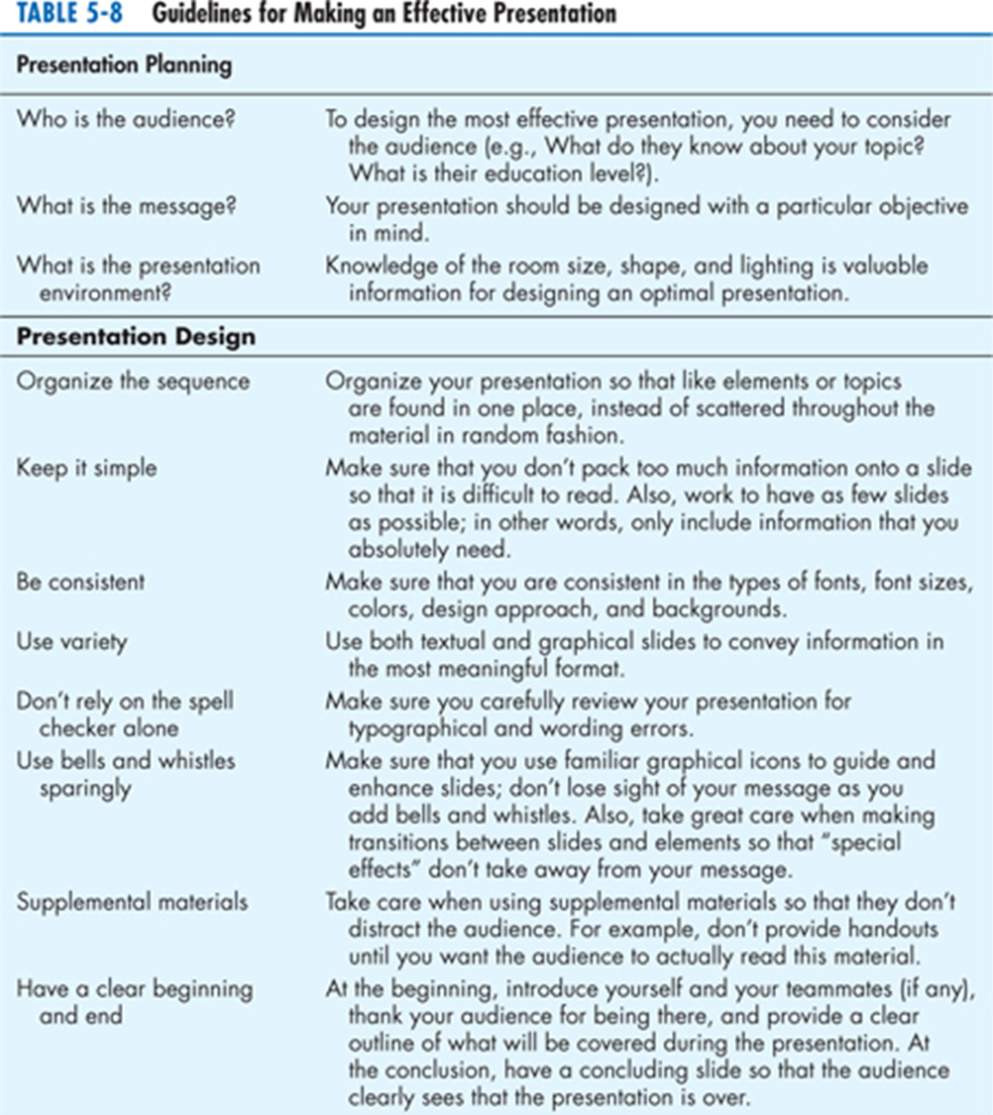 **Example**

